8.16 数字频率计VHDL程序与仿真
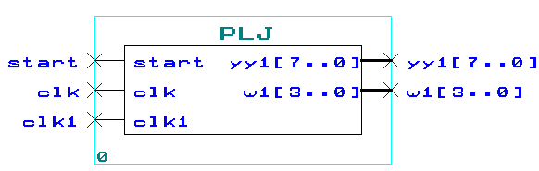
--文件名：plj.vhd。
--功能：频率计。具有4位显示，能自动根据7位十进制计数的结果，自动选择有效数据的
--高4位进行动态显示。小数点表示是千位，即KHz。
--最后修改日期：2004.4.9。
library ieee;
use ieee.std_logic_1164.all;
use ieee.std_logic_unsigned.all;
entity plj is
port ( start:in std_logic; --复位信号
clk :in std_logic; --系统时钟
clk1:in std_logic; --被测信号
yy1:out std_logic_vector(7 downto 0); --八段码
w1 :out std_logic_vector(3 downto 0)); --数码管位选信号
end plj;
architecture behav of PLj is
signal b1,b2,b3,b4,b5,b6,b7:std_logic_vector(3 downto 0); --十进制计数器
signal bcd:std_logic_vector(3 downto 0); --BCD码寄存器
signal q :integer range 0 to 49999999; --秒分频系数
signal qq : integer range 0 to 499999; --动态扫描分频系数
signal en,bclk:std_logic; --使能信号，有效被测信号
signal sss : std_logic_vector(3 downto 0); --小数点
signal bcd0,bcd1,bcd2,bcd3 : std_logic_vector(3 downto 0);
--寄存7位十位计数器中有效的高4位数据
begin

second:process(clk) --此进程产生一个持续时间为一秒的的闸门信号
begin
if start='1' then q<=0;
elsif clk'event and clk='1' then
if q<49999999 then q<=q+1;
else q<=49999999;
end if;
end if;
if q<49999999 and start='0' then en<='1';
else en<='0';
end if;
end process;

and2:process(en,clk1) --此进程得到7位十进制计数器的计数脉冲
begin
bclk<=clk1 and en;
end process;

com:process(start,bclk) --此进程完成对被测信号计脉冲数
begin
if start='1' then --复位
b1<="0000";b2<="0000";b3<="0000";b4<="0000";b5<="0000";b6<="0000";b7<="0000";
elsif bclk'event and bclk='1' then
if b1="1001" then b1<="0000"; --此IF语句完成个位十进制计数
if b2="1001" then b2<="0000"; --此IF语句完成百位十进制计数
if b3="1001" then b3<="0000"; --此IF语句完成千位十进制计数
if b4="1001" then b4<="0000"; --此IF语句完成万位十进制计数
if b5="1001" THEN b5<="0000"; --此IF语句完成十万位十进制计数
if b6="1001" then b6<="0000"; --此IF语句完成百万位十进制计数
if b7="1001" then b7<="0000"; --此IF语句完成千万位十进制计数
else b7<=b7+1;
end if;
else b6<=b6+1;
end if;
else b5<=b5+1;
end if;
else b4<=b4+1;
end if;
else b3<=b3+1;
end if;
else b2<=b2+1;
end if;
else b1<=b1+1;
end if;
end if;
end process;

process(clk) --此进程把7位十进制计数器有效的高4位数据送如bcd0~3；并得到小数点信息
begin
if rising_edge(clk) then
if en='0' then
if b7>"0000" then bcd3<=b7; bcd2<=b6; bcd1<=b5; bcd0<=b4; sss<="1110";
elsif b6>"0000" then bcd3<=b6; bcd2<=b5; bcd1<=b4; bcd0<=b3; sss<="1101";
elsif b5>"0000" then bcd3<=b5; bcd2<=b4; bcd1<=b3; bcd0<=b2; sss<="1011";
else bcd3<=b4; bcd2<=b3; bcd1<=b2; bcd0<=b1; sss<="1111";
end if;
end if;
end if;
end process;

weixuan:process(clk) --此进程完成数据的动态显示
begin
if clk'event and clk='1' then
if qq< 99999 then qq<=qq+1;bcd<=bcd3; w1<="0111";
if sss="0111" then yy1(0)<='0';
else yy1(0)<='1';
end if;
elsif qq<199999 then qq<=qq+1;bcd<=bcd2; w1<="1011";
if sss="1011" then yy1(0)<='0';
else yy1(0)<='1';
end if;
elsif qq<299999 then qq<=qq+1;bcd<=bcd1; w1<="1101";
if sss="1101" then yy1(0)<='0';
else yy1(0)<='1';
end if;
elsif qq<399999 then qq<=qq+1;bcd<=bcd0; w1<="1110";
if sss="1110" then yy1(0)<='0';
else yy1(0)<='1';
end if;
else qq<=0;
end if;
end if;
end process;

m0: process (bcd) --译码
begin
case bcd is
when "0000"=>yy1(7 downto 1)<="0000001";
when "0001"=>yy1(7 downto 1)<="1001111";
when "0010"=>yy1(7 downto 1)<="0010010";
when "0011"=>yy1(7 downto 1)<="0000110";
when "0100"=>yy1(7 downto 1)<="1001100";
when "0101"=>yy1(7 downto 1)<="0100100";
when "0110"=>yy1(7 downto 1)<="1100000";
when "0111"=>yy1(7 downto 1)<="0001111";
when "1000"=>yy1(7 downto 1)<="0000000";
when "1001"=>yy1(7 downto 1)<="0001100";
when others=>yy1(7 downto 1)<="1111111";
end case;
end process;
end behav;

程序仿真
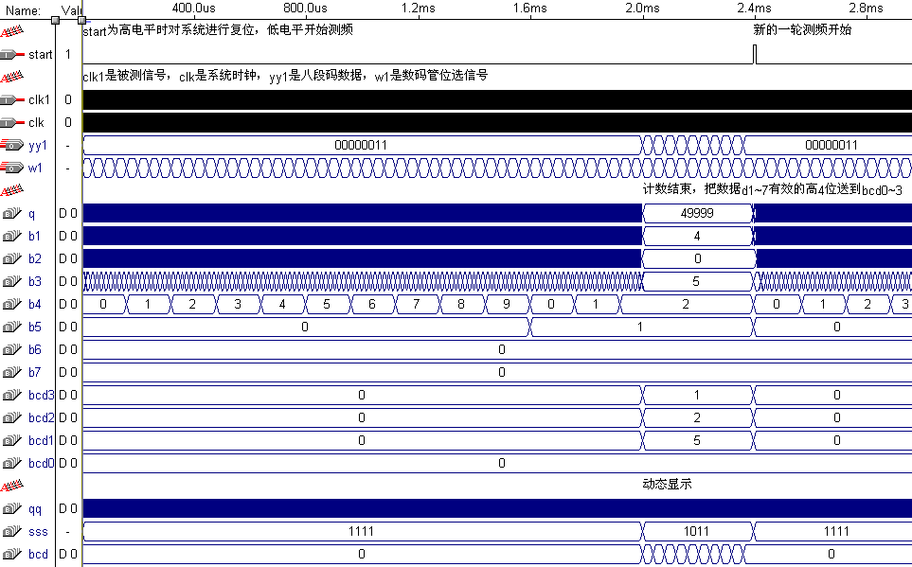
注：仿真中秒分频为50000，动态显示的分频系数也相应调小。
频率计仿真全图
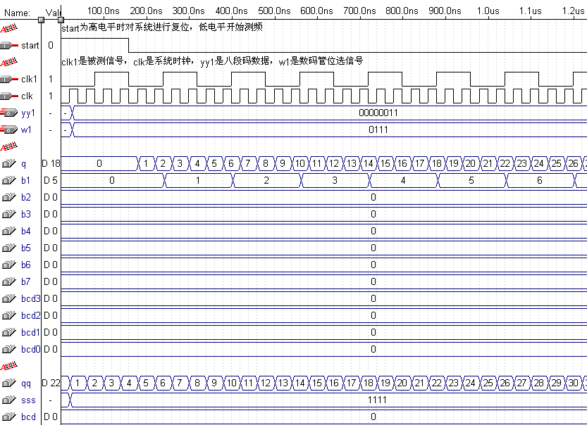
频率计仿真-开始计数部分
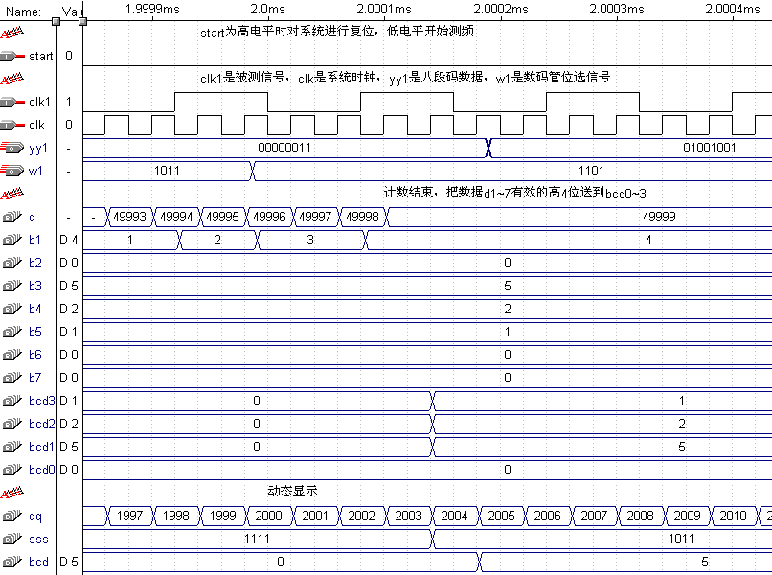
频率计仿真-结束结束、动态显示部分
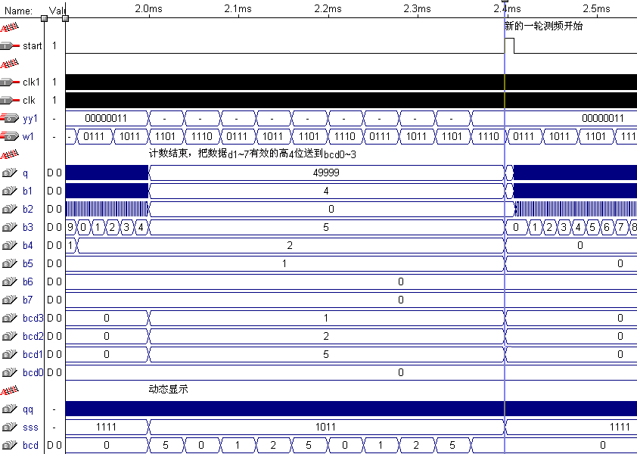
频率计仿真-复位、重新测频部分

